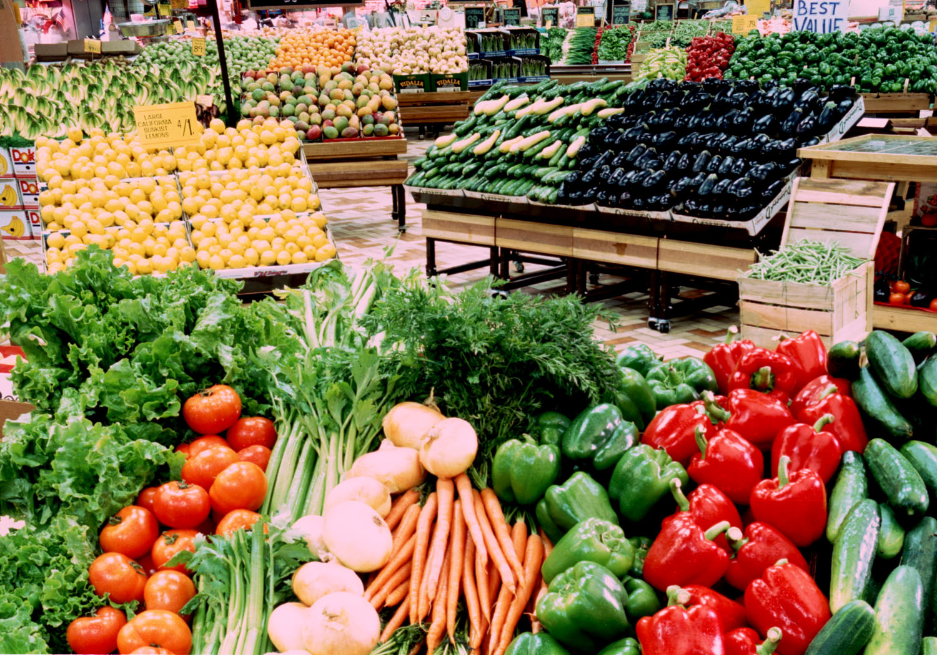

2026 Northern Plains Farmers Market at West Acres

Vendor Information Packet
Apply at The Market at West Acres Application – Fill out form

About
We believe in building community relationships while providing beautiful, fun and functional access to nourishing, regionally grown and seasonal food products. NPBGS operates a vibrant market on the property of West Acres Development, LLP that contributes to the success of regional food growers, gardeners, and producers, and supports a healthy and vibrant community, all while serving as community gathering place.

Our Partner
West Acres works closely with our partner, Northern Plains Botanic Garden Society, to bring our community this event (www.NPBGS.org). NPBGS is a 501(c)3 non-profit organization. Founded in 1998, NPBGS’s vision is to enrich and promote community through the culture and utilization of plants. Their goal is to establish and operate a regional botanic garden, arboretum, and conservatory in the FM area. NPBGS is committed to the understanding, promotion, and appreciation of horticulture in the Northern Great Plains. They serve the public as a non-profit by providing gardening opportunities and educational workshops. Admission to the gardens is free and open to all.

Location, Dates and Times
Open: Mid to late June through October. End date TBD, produce availability and weather dependent. The Northern Plains Farmers Market at West Acres is open to the public Tuesday, Thursday, and Saturday,
9am – 3pm. Located in the west parking lot of West Acres just off 42nd St. S., between 15th and 17th Ave.
The NPFM is a “rain–or–shine” market. Only in extreme situations where health and safety of the vendors and customers may be at risk will the market be canceled due to conditions such as severe weather alerts.

Fees:
- The daily participation fee in the market is $25. 100% of this fee goes toward support of The Northern Plains Botanic Garden Society. This fee is payable by cash or check (made out to NPBGS).
- Each vendor will pay a one-time marketing fee of $100 to West Acres Development, LLP at the time of license and Certificate of Insurance submission.

Marketing
West Acres is a regional hub for shopping and attracts visitors regularly from within a 100-mile area. West Acres Development, LLP will promote The Northern Plains Farmers Market at West Acres through West Acres’ website and social media pages, electronic pylon signs (located on 13th Avenue and I-29), paid online ads, a public relations campaign, in-mall signage (including 22”x28” signs and table tents), and outdoor banners.

Community Events in Conjunction to the Market
West Acres may host additional events in conjunction with the Market. Those events may include, but are not limited to: Art Events, Food Demos, Nutrition Info, Gardening Info.

Criteria for Vendor Selection Process
The Northern Plains Farmers Market at West Acres is committed to creating a diverse marketplace with the highest quality, regionally produced products available. The selection process is rigorous and takes into consideration many factors, including product quality, sourcing, growing practices, presentation, safety, compliance, customer service, timing of application, and the right product mix to ensure a successful market.

West Acres will review applications as soon as they are received. Vendors will receive notice of acceptance within two weeks of receiving the application. Once accepted, the vendor will be required to complete and submit a West Acres Market license agreement, provide a Certificate of Insurance, and $100 marketing fee.

- Priority vendor approval is given to those regional farmers, community gardeners, and producers who bring products that they themselves grow including fruits, vegetables, herbs, flowers, plants and related products.
- Products must not be obtained through supermarkets or wholesalers.
- Products made from regionally grown produce will be considered and may be given priority (canned goods, skincare and bath products, and honey products).
  - Canned goods recipes require documentation of pH testing through NDSU’s extension service, with a pH of 4.6 or less.
  - Using recipes deemed safe by NDSU’s extension service are highly encouraged. For more information, visit: http://www.ag.ndsu.edu/food/food-preservation
- Other agricultural products such as beef, chicken, pork or eggs, per approval.
- Raw honey products should clearly be labeled as such.
- Consideration may be given to local non-profits who wish to participate. The application and daily fee apply.
- Local craft and non-food vendors will be considered on a case-by-case basis.
- West Acres tenants who wish to participate will be allowed to do so on any market day.

Product Quality, Display and Safety
- Vendors are responsible for providing everything used in set-up and operation of their market display, including but not limited to canopies, tables, and displays.
- Vendors accepted into NPFM shall have:
  - Consistently high product quality: fresh, flavorful, and ripe. Each seller is individually responsible for conformance to all local, state and federal laws and regulations. For edible items, this includes conformance to Cass County and ND regulations/standards.
  - Clean and attractive displays. Creative packaging and displays, including baskets, are encouraged.
  - Differentiation in produce and products through creative and attractive display, signage and product type, packaging, etc. Signate not to exceed 8ft high or obstruct traffic flow.
  - Clearly marked, visible and readable pricing for the market shopper. Vendors must agree to price their items at a competitive level, comparable with other retail outlets. In addition, vendors are not allowed to cut prices or give produce or other items away for free or at below-cost pricing with the intent to undercutting other vendors.
  - Identification signs. Vendors must indicate their name and where their production is located and/or product is sourced.
- Vendors should expect compliance checks/visits by the Cass County Health Department.
- Vendors must display any inspection or certifications to customers.
- Vendors are required to know, understand, and abide by NPFM’s, and all federal, state, and local regulations. Vendors must maintain a history of compliance.
- Vendors must ensure that their area is safe and secure. Tarps, canopies, etc. must be securely tied down.

Vendor Conduct
- Vendors and their representatives are expected to conduct themselves in a safe and courteous manner. Any language or behavior considered offensive will be grounds for dismissal from NPFM.
- Positive and fair vendor conduct toward customers, fellow vendors, market staff, and volunteers is mandatory, including courteous, strong customer service and knowledgeable staff.
- Any vendor who does not comply with West Acres or NPFM policies and regulations may be subject to immediate dismissal from participating in the market; and/or termination of future participation in the market. Any fees paid are non-refundable.

Additional Market Rules, Policies and Requirement
Alcohol/Intoxicant Consumption: Consumption of alcoholic beverages and/or other intoxicants is prohibited on The Market premises except for specific events in which there is sampling or pours being served by a Market vendor. Anyone judged to be "under the influence" will be asked to leave the premises immediately.
Attire: Appropriate clothing and foot coverings must be worn at all times while on The Market premises, including shirts and shoes.
Children: Young children must be supervised at all times.
Hours of Operation: Vendor displays must be open during market hours (9am – 3pm); unless the vendor has sold out of product (see “leaving early).
Leaving Early: It is vital to the success of NPFM, and out of respect for other vendors, that all vendors remain open for business until the official end of the market. Unless you have completely sold out of product, it is suggested you remain open. (If it is unavoidable for you to leave early on a given market day, contact the Market Manager for pre-approval). If you have completely sold out of all available products, contact the Market Manager before starting to pack up/break down.
Odors: The vendor shall not operate any equipment which emits an odor deemed offensive in nature.
Promotion and Identification Signs: All vendor promotion must occur within the space assigned to the producer and not in any common area. Professional-looking signage is highly encouraged. Only handbills relating specifically to the vendor business is permitted and must be limited to the vendor’s stall area.
Returns/Exchanges: The vendor shall, at all times, offer customers a satisfactory return and/or exchange on all purchases within 30 days with receipt and the product. In the event the vendor cannot satisfy the customer with an exchange, the vendor shall be required to fully refund to the customer the complete purchase price in the form of payment made to the Vendor. This policy shall not apply if due to customer negligence.
Smoking: Smoking is not allowed in the market area.
Trash/Waste: All sellers are required to keep their immediate area clean and safe. Vendors must provide their own trash containers for their own use and remove all trash themselves at the end of the market day. Vendors using plastic bags for the convenience of their customers shall insure that such bags do not litter The Market. Before the producer may leave the market, both the stall and the surrounding area must be totally free of any produce, debris, and trash.
Market Regulations may change at any time. Market participants will be given as much notice as possible of any changes.

To Apply - The Northern Plains Farmers Market at West Acres – Fill out form

Questions and Information
Email: TheMarket@westacres.com
Call: 701-282-2222
Fax: 701-282-2229
Click: www.westacres.com

Northern Plains Botanic Garden Society
www.NPBGS.org
info@npbotanicgarden.com

Quick Link List
Fact Sheet for Farmers Markets, Fargo and West Fargo – Fargo Cass Public Health Department
https://download.fargond.gov/0/foods_allowed_at_fargo_west_fargo_farmers_markets.pdf

NDSU Extension Service Food Preservation Resources – USDA-tested and approved for safety
www.ag.ndsu.edu/food/food-preservation
ph testing contact
Julie Garden Robinson
701-231-7187
Julie.gardenrobinson@ndsu.edu

North Dakota Farm to Market Guide:
http://www.nd.gov/ndda/files/Marketing/FarmToMarketBrochure.pdf

Fargo Cass Public Health, Environmental Health Division “Eat Smart” Resources
https://fargond.gov/city-government/departments/fargo-cass-public-health/health-promotion/metro-in-motion/eat-smart
701-476-6729
Food Inspection
Doug Jensen
701-241-1387

North Dakota Farmers Market & Growers Association:
https://www.ndfarmersmarkets.org/

Minnesota’s Farmers Market Association
http://www.mfma.org

